Group Members

**SQL Project – Google Store Visitor Data**

BUAN 6320.006

#07

Kunal Chauhan

Ayushi Sharma

Contents

Data Model 3

Assumptions/Notes About Data Entities and Relationships 3

Entity-Relationship Diagram 3

Physical Database 4

Assumptions/Notes About Data Set 4

Screen shot of Physical Database objects 4

Data in the Database 4

SQL Queries 5

Query 1 5

Question 5

Notes/Comments About SQL Query and Results (Include # of Rows in Result) 5

Translation 5

Screen Shot of SQL Query and Results 5

Query 2 6

Question 6

Notes/Comments About SQL Query and Results (Include # of Rows in Result) 6

Translation 6

Screen Shot of SQL Query and Results 6

Query 3 7

Question 7

Notes/Comments About SQL Query and Results (Include # of Rows in Result) 7

Translation 7

Screen Shot of SQL Query and Results 7

Query 4 8

Question 8

Notes/Comments About SQL Query and Results (Include # of Rows in Result) 8

Translation 8

Screen Shot of SQL Query and Results 8

Query 5 9

Question 9

Notes/Comments About SQL Query and Results (Include # of Rows in Result) 9

Translation 9

Screen Shot of SQL Query and Results 9

Query 6 10

Question 10

Notes/Comments About SQL Query and Results (Include # of Rows in Result) 10

Translation 10

Screen Shot of SQL Query and Results 10

Query 7 11

Question 11

Notes/Comments About SQL Query and Results (Include # of Rows in Result) 11

Translation 11

Screen Shot of SQL Query and Results 11

# Data Model

## Assumptions/Notes About Data Entities and Relationships

## Entity-Relationship Diagram

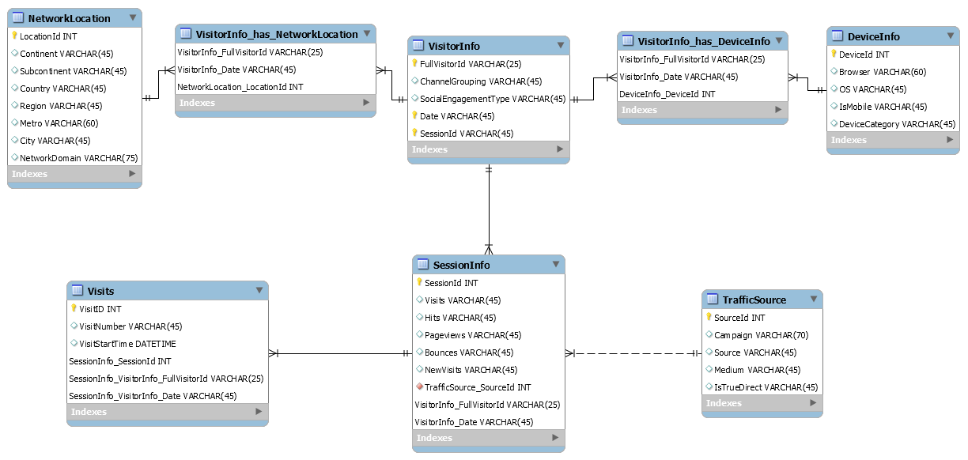

# Physical Database

## Assumptions/Notes About Data Set

* SessionId can’t alone identify the unique rows. We need to take Date along with SessionId
* We should consider VisitId, fullVisistorId and Date as a composite primary key identify unique visits
* We removed duplicate values in the DeviceInfo, NetworkLocation and TrafficResource tables by uniquely identifying the rows
* DeviceId is generated based on the unique rows present in the DeviceInfo Table
* LocationId is generated based on the unique rows present in the NetworkLocation Table
* SourceId is generated based on the unique rows present in the TrafficResource Table

## Screen shot of Physical Database objects

Device Info 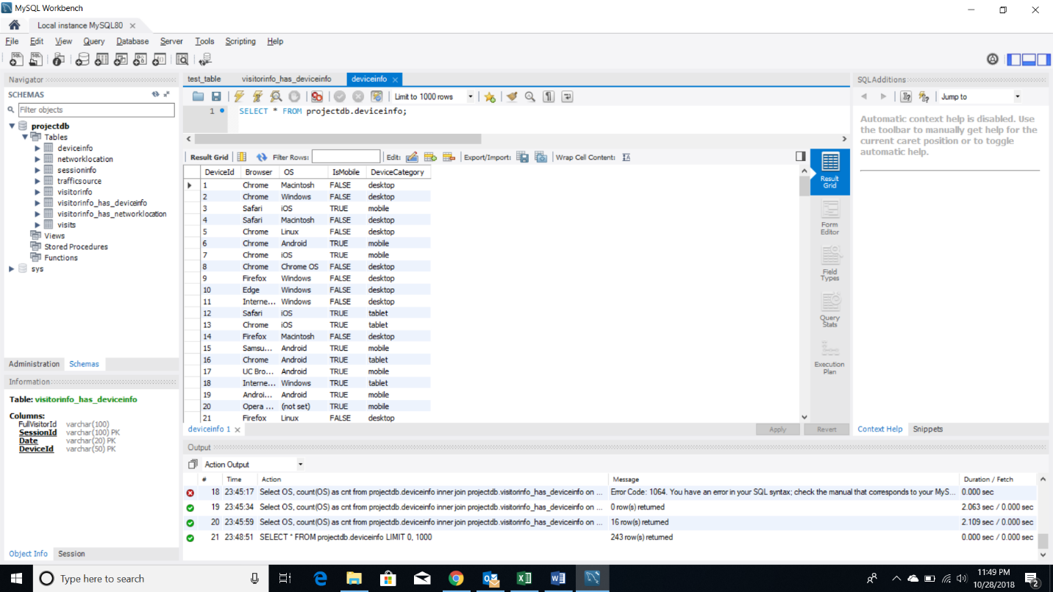

NetworkLocation

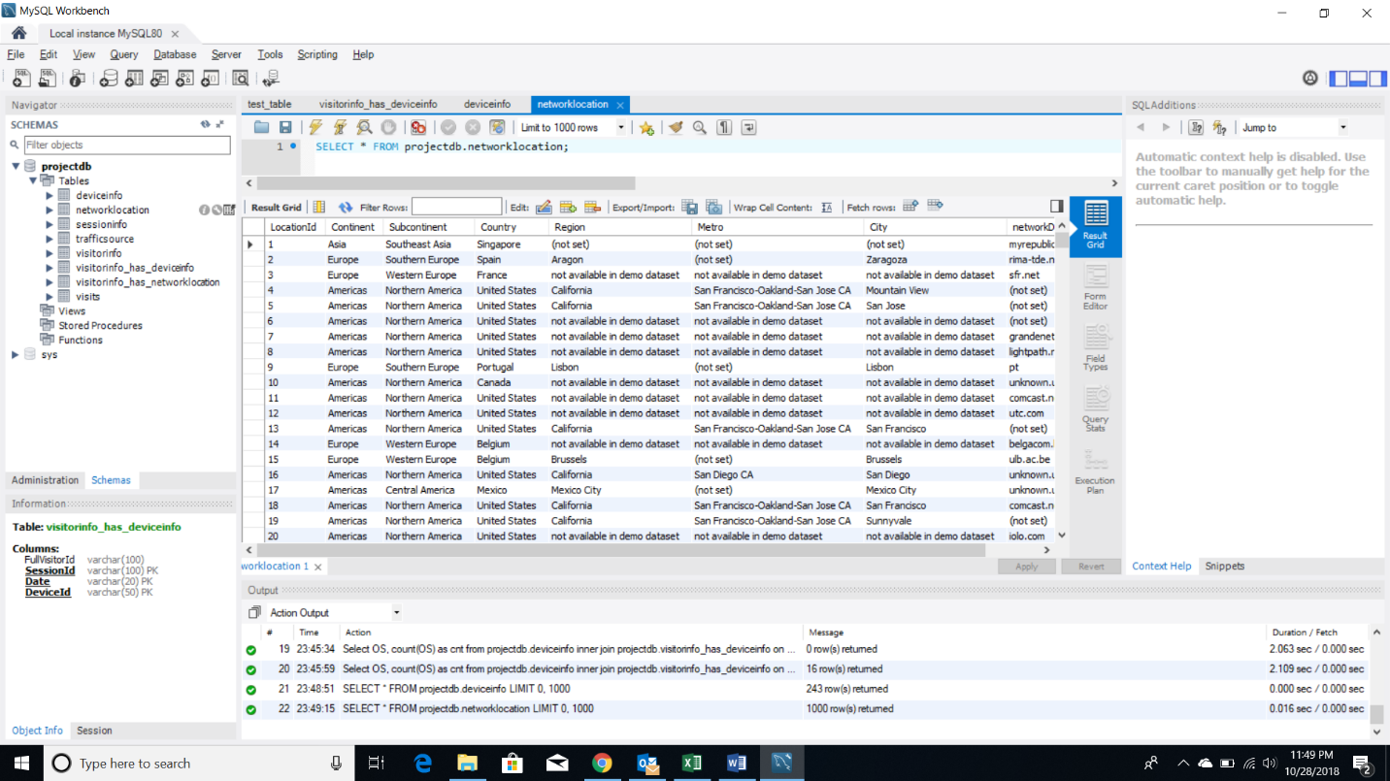

Session Info

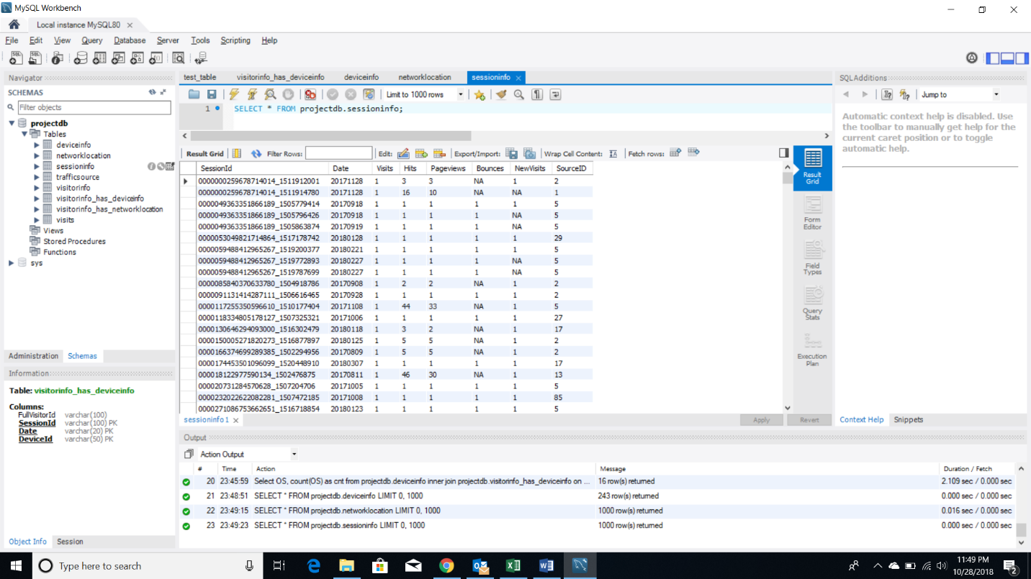

TrafficSource

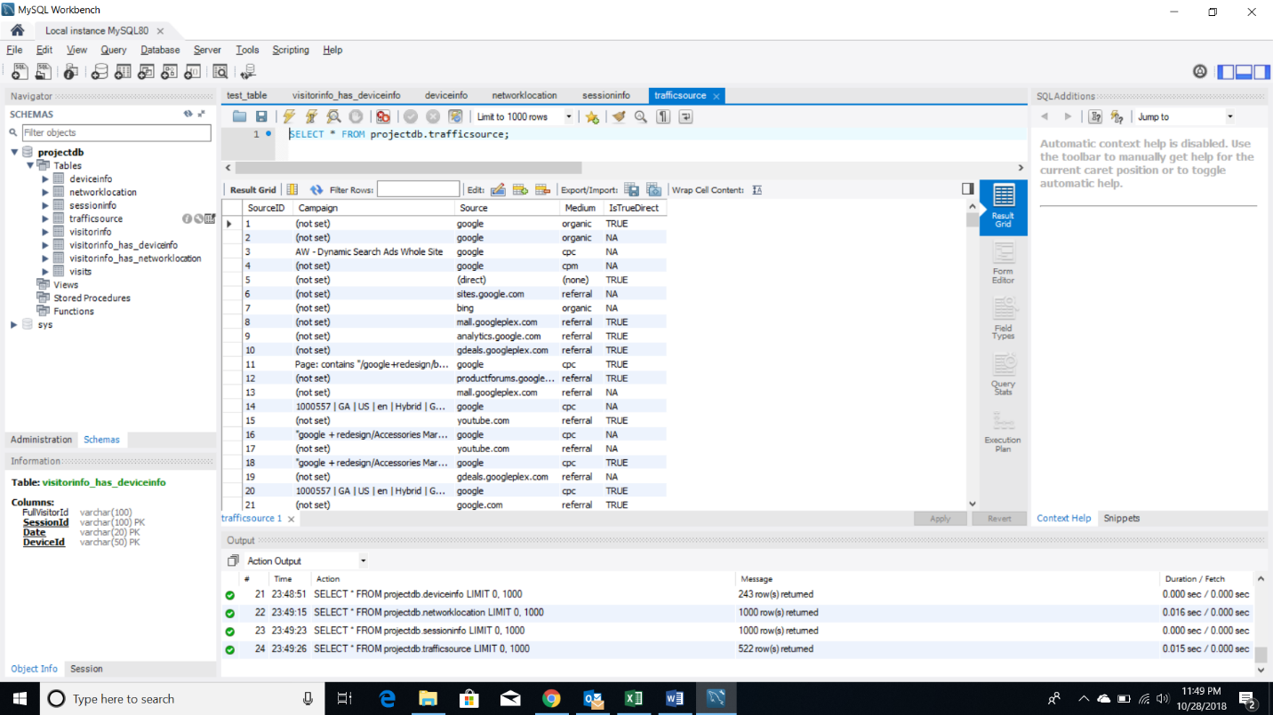

Visitor Info

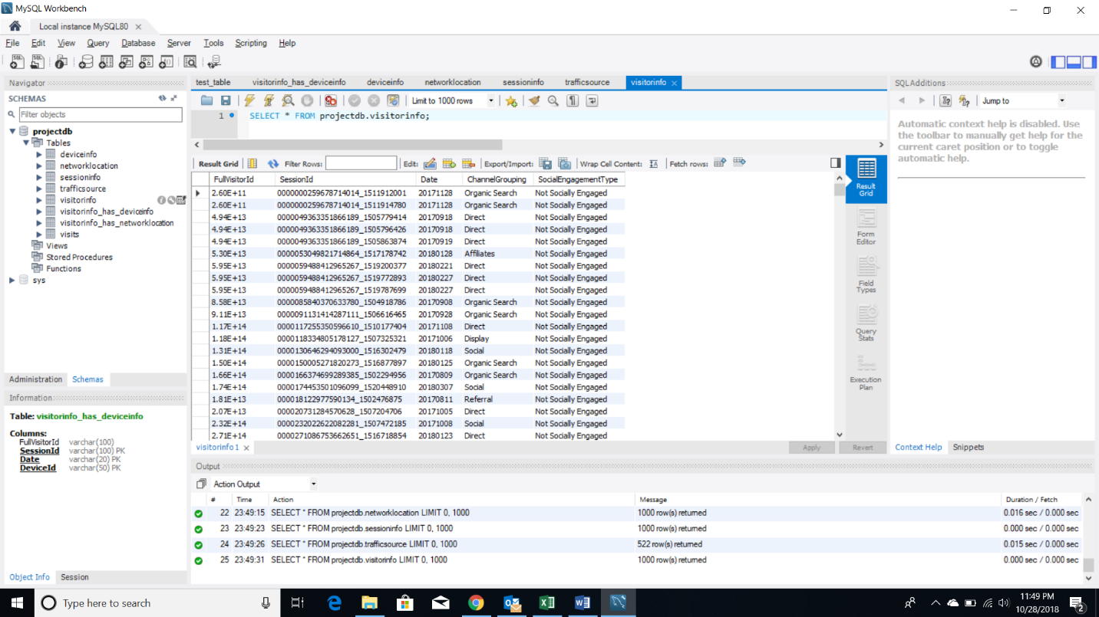

Device Info

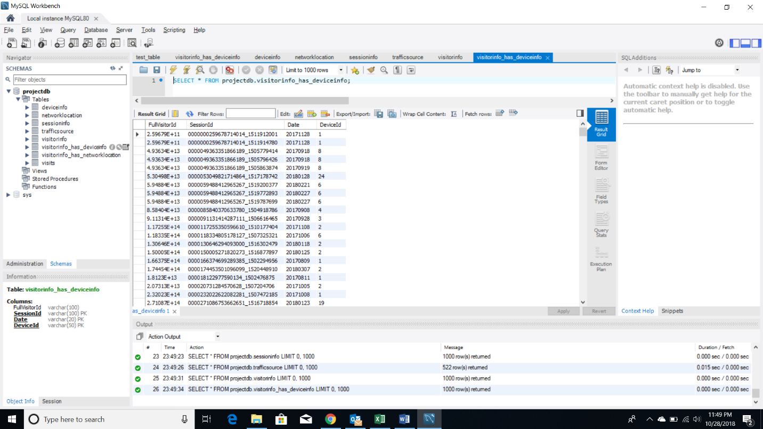

Visits

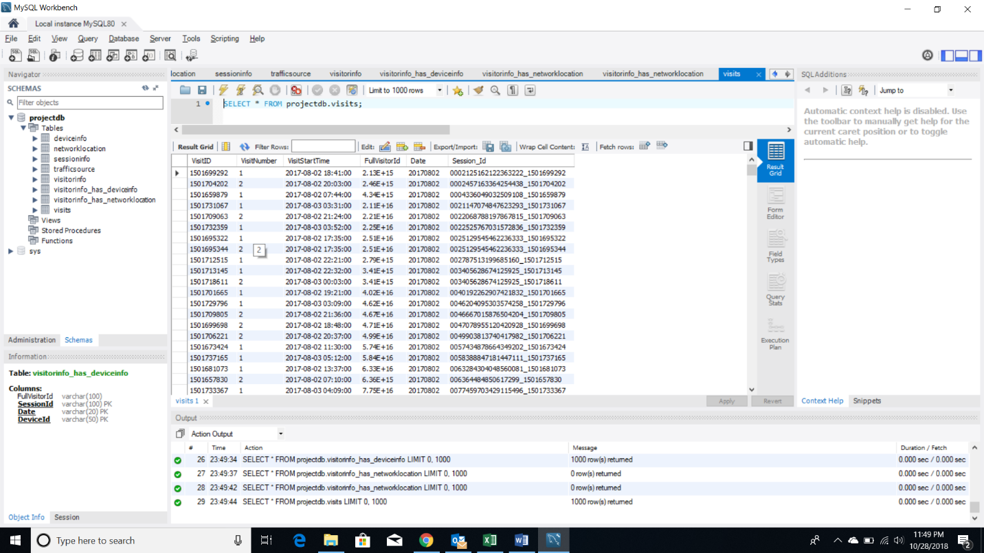

## Data in the Database

|  |  |  |  |
| --- | --- | --- | --- |
| **Table Name** | **Primary Key** | **Foreign Key** | **# of Rows in Table** |
| VisitorInfo | FullVisitorId+SessionId+Date | SessionInfo_SessionId+SessionInfo_Date | 804684 |
| Visits | VisitID+fullVisitorId+Date | VisitorInfo_FullVisitorId+SessionInfo_Date | 804684 |
| NetworkLocation | LocationId |  | 36699 |
| DeviceInfo | DeviceId |  | 243 |
| TrafficSource | SourceID |  | 522 |
| SessionInfo | SessionId+Date | TrafficSource_SourceID | 804684 |

# SQL Queries

## Query 1

### Question

Which user had the minimum number of visits and when?

### Notes/Comments About SQL Query and Results (Include # of Rows in Result)

### Translation

Select VisitorId and Date of the Visitor from VisitorInfo table having minimum number of VisitsScreen Shot of SQL Query and Results

## Query 2

### Question

Which operating system (devices) was the most popular amongst store visitors with mobile devices?

### Notes/Comments About SQL Query and Results (Include # of Rows in Result)

### Translation

Select Operating System from the DeviceInfo Table which was most popular amongst Store Visitors with Mobile Devices

### Screen Shot of SQL Query and Results

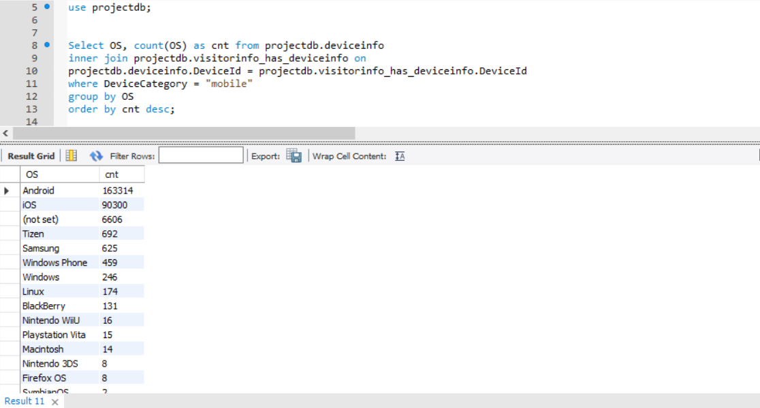

## Query 3

### Question

Which date had the least and most number of visitors?

### Notes/Comments About SQL Query and Results (Include # of Rows in Result)

### 

### Translation

Select Dates from VisitorInfo which has minimum and maximum number of visitors

### Screen Shot of SQL Query and Results

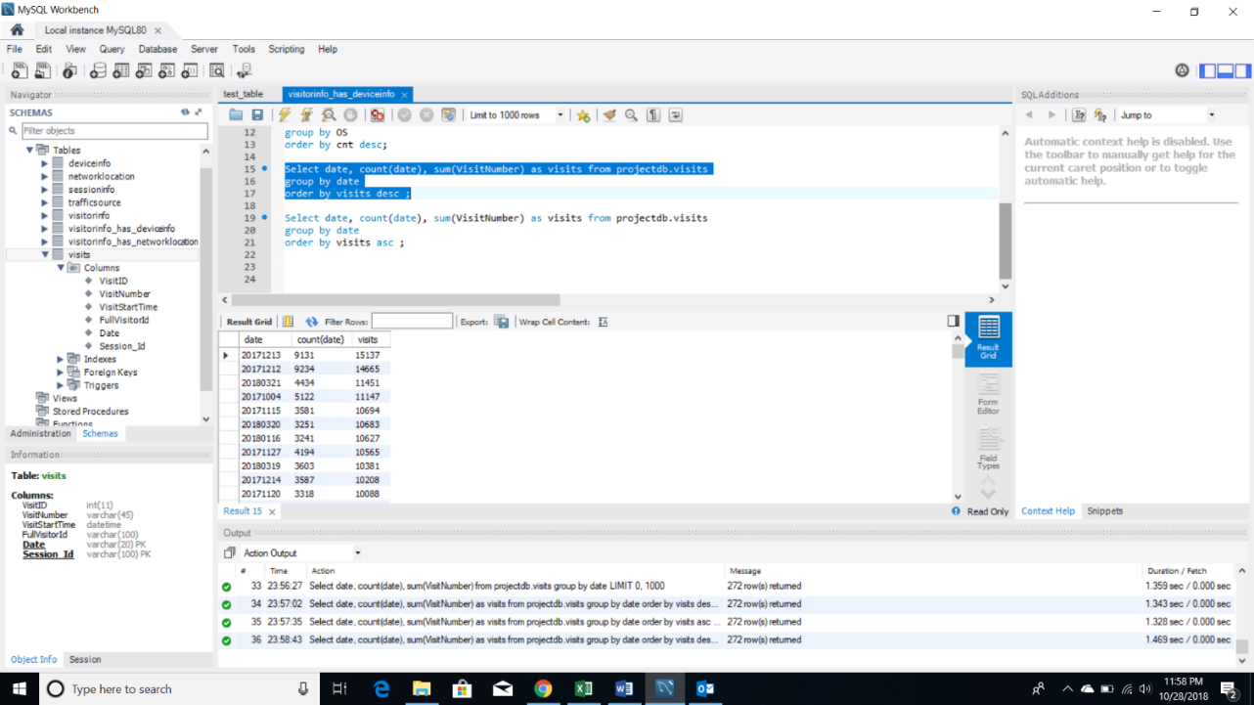

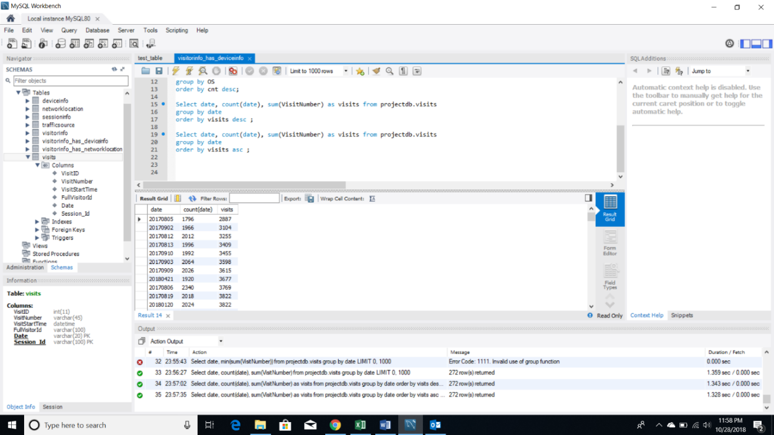

## Query 4

### Question

Users of which operating system were the least socially engaged?

### Notes/Comments About SQL Query and Results (Include # of Rows in Result)

### Translation

Select Operating System from DeviceInfo table where the visitors from VisitorInfo table are least socially engaged

### Screen Shot of SQL Query and Results

## Query 5

### Question

Provide a breakdown of unique visitors by mobile vs nonmobile users

### Notes/Comments About SQL Query and Results (Include # of Rows in Result)

### Translation

Select Unique Visitors from VisitorInfo table which are grouped by isMobile from DeviceInfo table

### Screen Shot of SQL Query and Results

## Query 6

### Question

How many users used only iOS devices to visit the store?

### Notes/Comments About SQL Query and Results (Include # of Rows in Result)

### Translation

Select number of Visitors from VisitorInfo table where Device Operating System from DeviceInfo table is iOS

### Screen Shot of SQL Query and Results

## Query 7

### Question

Which user generated the least amount of hits and when?

### Notes/Comments About SQL Query and Results (Include # of Rows in Result)

### Translation

Select visitor id and date from VisitorInfo table whose has the least number of hits

### Screen Shot of SQL Query and Results

## Query 8

### Question

### Visitors from which country visted the store more than once?

### Notes/Comments About SQL Query and Results (Include # of Rows in Result)

### Translation

Select Country from NetworkLocation table from where we have more than one visit to the store

### Screen Shot of SQL Query and Results